Hardware Documentation

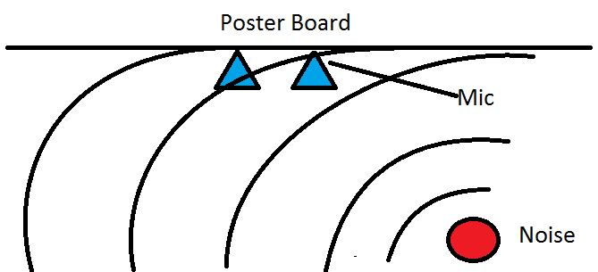

Configuration 1:

Y Splitter (<http://www.amazon.com/Seismic-Audio-SA-iEM2EF-Splitter-Android/dp/B008RPIPSE>) with two of the Lab Microphones

Configuration 2:

Perf Board with 2 Microphones from DigiKey (MIC COND ANALOG OMNI -44DB)

<https://www.digikey.com/product-detail/en/cui-inc/CMB-6544PF/102-1722-ND/1869982>